ETDR Formatting Checklist

At the stage in which you are ready to take your research work into a thesis or dissertation document and work through the process to format it for submission many students will download an ETDR template from https://www.k-state.edu/grad/academics/etdr/template and use it to present their research proposal. Although the template is not required, most graduate students choose to use the template as it helps provide guidance for successful submission.

When ETDR templates are used. Some students use the templates before they have formally defended their work, and others after. This checklist may be used at any point in the sequence but is focused mostly on formatting and not any of the other aspects of graduate student research, documentation, defense, and presentation to the research community through their theses, dissertations, and reports. In the figure below, the general sequence may be explored. (Figure 1)

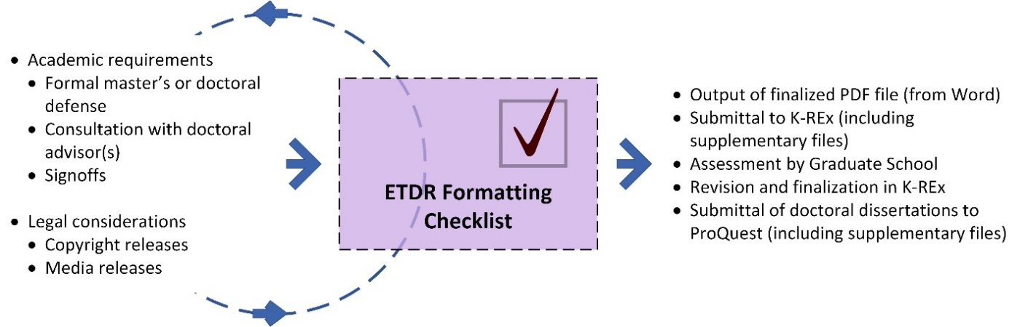
Figure 1. Role of ETDR Formatting Checklist in the General Order of ETDR Sequence

Why ETDR templates? This Electronic Theses, Dissertations, and Reports (ETDR) Formatting Checklist provides a fast way to make sure that you’ve properly formatted your master’s thesis, report, or doctoral dissertation, for

- submittal to K-REx,
- review by the K-State Graduate School,
- necessary revisions,
- finalized submittal to K-REx, and
- final submittal to ProQuest (doctoral dissertation only, not master’s theses or reports).

This ETDR Formatting Checklist covers the following areas: file navigation, completeness of manuscript, text formatting, digital image quality, pagination, margins, source citation formatting, HTML links, and file naming. This checklist is set up to include additional main areas and subareas as required by the particular discipline, committee, and learner / researcher. (Table 1)

Table 1. ETDR Formatting Checklist
Main Areas | Related Subareas | Check
 |  | MS Word or LaTeX | PDF
File Navigation (ability to go to manuscript contents with a click from the Table of Contents and Lists)
 | Text styles for text hierarchy
 | Placement of captions
 | Working Table of Contents (TOC)
 | Working List of Figures
 | Working List of Tables
 | List of Abbreviations / Terms or Nomenclature / Equations (if used)
Completeness of Manuscript
 | All required sections included
 | Optional sections added, as needed
Text Formatting
 | Proper text style to enable file navigation (H1, H2, H3; body text, etc.)
 | Proper capitalization
 | Consistent text formatting
 | Consistent font use
Digital Image Quality
High resolution (and high resolution settings in Word) > 350 ppi / dpi
Up to 1000 ppi . dpi or even higher for microscopy image data
 | Visual sharpness
 | Color as CMYK (cyan, magenta, yellow, and black), not RGB (red, green, and blue)
 | Sufficient color contrast (accessibility)
 | Proper aspect ratio (no accidental stretching or skewing)
 | Accurate in-image-annotations and labeling (and readability)
 | Proper caption formatting in accordance with bibliography method directions (varies based on the discipline)
 | Appropriate technical captioning (for file navigation)
Main Areas | Related Subareas | Check
 |  | MS Word or LaTeX | PDF
Table Layout
Portrait or landscape layout for easier viewability of tables (and / or figures), particularly those with a large number of column headers (which add to table width)

[Table height is less of an issue because tables may flow from one page to another.]
 | Consistent font and number sizes for the table data
 | Human readability of table data and tables
 | Proper caption formatting in accordance with bibliography method directions (varies based on the discipline)
 | Appropriate technical captioning (for file navigation)
Pagination
 | Correct pagination (no visible page numbers until Table of Contents, at which point small Roman numerals (i, ii, iii, etc.) are used until Chapter 1, then natural whole numbers are used (1, 2, 3, etc.), starting with 1.
Margins
 | 1” all around edges
May have 1.5” in the left for physical printing and binding
 | Consistent margins
Source Citation Formatting
 | Proper source citation formatting in-body
 | Proper source citation formatting in bibliography / references
 | * This is especially important for those using online bibliography services because of different functioning of these programs and the complex nuances of variant source citation methods in different disciplines.
HTML Links
 | Live HTML links (so actually pointing to a destination on the Internet and Web in a working way, not to a non-live site)
 | Activated HTML links (linked in a clickable way from Word, LaTeX, and PDF formats)
File Naming | Format must be FirstnameLastNameGraduationYearYYYY.pdf in the exported file (from MS Word or LaTeX formats)
Other

Supplementary files to the ETDR. Do not embed audio and video and multimedia and slideshow files into either Word or LaTeX or .pdf. Oftentimes, such files do not play well within the file

K-REx and ProQuest enable students to upload supplementary files. These may be data tables, datasets, slideshows, audio files, video files, image collections, and other common digital file formats. There is a limit on the number of such files, but students can upload about 10 or so files as supplements to the ETDRs.

Multi-language considerations. If you are using multiple languages, please check how each is represented accurately.

Preparation for submission to K-REx repository. Once the .pdf is approved, work on a listing of “key words” that represent your work, so you can advance to the next step of inputting your thesis, dissertation, or report into K-REx. Those who are earning doctorates will also submit to ProQuest once their dissertation has been approved in K-REx.

(02.2024)

