Faculty Instructions

Proctorio Settings within Connect for Read & Write Chrome Extension & Screen shot Reader by Text Help

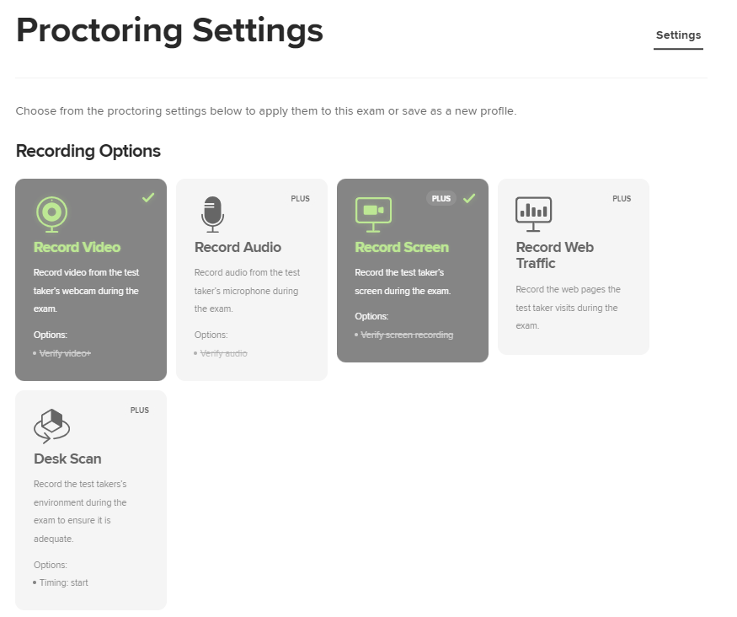Precursor: When creating an exam for a student needing a text to speech accommodation you will want to utilize the following settings ONLY. If you do not want these same settings for all the other students, we encourage you to copy your exam so that you can change the settings for only a select few of students needing this specific accommodation. You would want to password protect this copy with the moderate exam settings and only provide that to the students receiving this accommodation.

1. Proctoring Settings: You can use any of the recording options.
2. 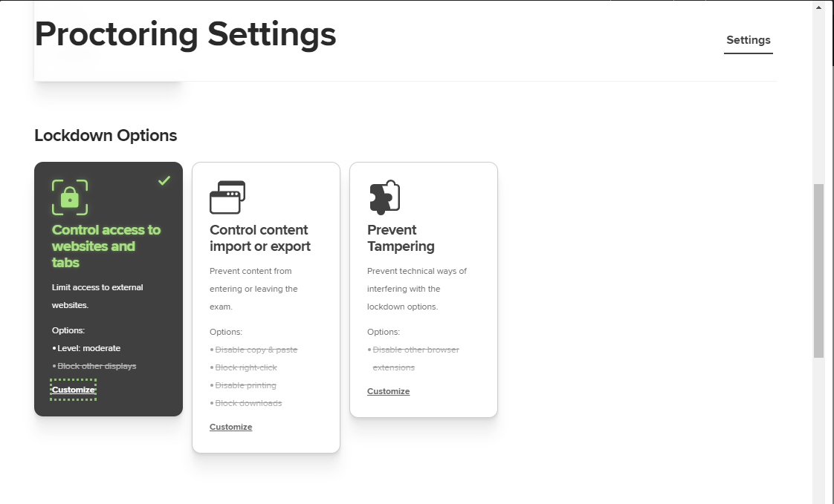Lock Down Options: Click customize.
3. Once you are in customize you want your options to be Moderate, and only allow the use of other programs. Be sure to toggle the block the use of other displays to on. Once you do that a red X will be indicated above the toggle showing that you have not allowed other displays.

