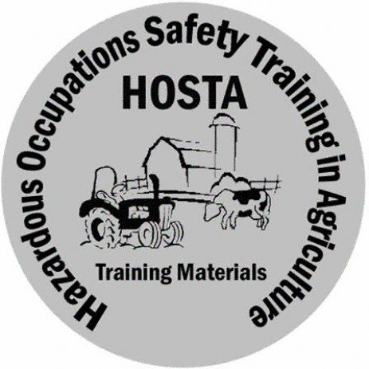

This certificate is for ceremonial purposes only and does not replace the

US Department of Labor’s Certificate of Training.

National Safe Tractor and Machinery Operation Program

Certificate of Completion

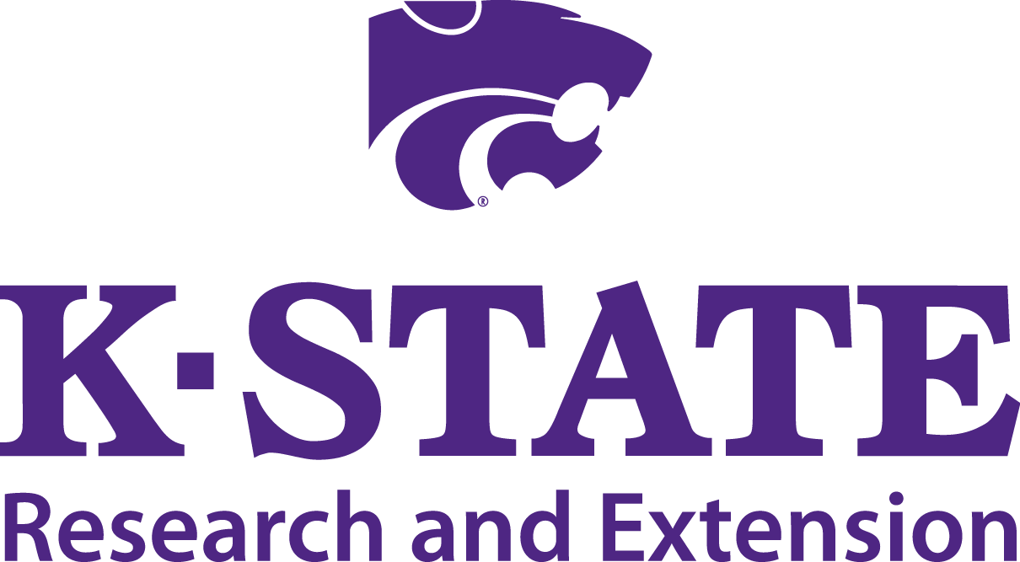

Signature

Date

This certificate is proudly presented to