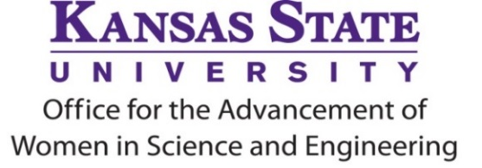
KAWSE Recognition Award
for 2024 – 2025 Academic Year

The K-State Office for the Advancement of Women in Science and Engineering (KAWSE) is pleased to issue the Request for Nominations for the 2024 - 2025 KAWSE Recognition Award. The KAWSE Office works to increase the participation, retention and advancement of girls and women in Science, Technology, Engineering and Math (STEM).

Purpose of Award
This award honors exceptional efforts undertaken by a K-State faculty or staff member to enrich girls’ and women’s lives in STEM disciplines. Recipients will be recognized with an engraved plaque and a $500 award.

Eligibility
Any K-State faculty or unclassified professional staff member is eligible for the award.

Deadline for Nominations
All nomination materials are due by 5pm on Monday, March 3, 2025, and should be sent to kawse@k-state.edu with the subject line “Nomination for KAWSE Recognition Award.”

Criteria for Nomination
Evidence of demonstrated exceptional efforts to enhance women’s lives in STEM, and thereby to enhance the justice, equity, diversity, and inclusion (JEDI) and women in STEM may include, but is not limited to, two or more of the following:
- Outstanding contributions to KAWSE’s GROW, EXCITE, SUCCEED, or ADVANCE programs
- Development of new, innovative JEDI programs in STEM
- Maintenance of current JEDI programming in STEM
- Development of JEDI activities that support partnerships across programs to include STEM programs
- Published research on girls and women in STEM
Nomination Process
Any K-State faculty or unclassified professional staff member may self-nominate or be nominated by a colleague, department head or other administrator. The nomination must include information on how the individual has enriched the lives of women in STEM disciplines. Nominations will be reviewed by a screening committee. Individuals who have previously received this award will generally not be eligible for a subsequent award within a three-year time period.

Contents of Nomination Packet
- Letter of nomination describing in detail why the nominee is deserving of the award (maximum of two pages)
- Relevant materials, such as published research, program or activity descriptions

Time Frame
January/February – call for nominations on ADVANCE listserv & in K-State Today
End of February/Beginning of March – nomination materials due to kawse@k-state.edu. Subject line should read “Nomination for KAWSE Recognition Award.” See exact due date in request for nominations announcement.
March/April – review of materials by KAWSE Award Screening Committee
End of April – announcement of KAWSE Award recipient
September – honoree recognized at KAWSE’s Annual Women of Distinction Recognition Ceremony

For more information, contact
KAWSE • 215 Fairchild Hall • kawse@k-state.edu • 785-532-6088

