Undergraduate Assessment of Student Learning Report

Report for Academic Year: 2023-2024

A. Program Information
Department: Sociology, Anthropology, and Social Work
Program: Addiction Counseling
Contact Name: Cheryl Calhoun
Contact Email: cherylcalhoun@ksu.edu
Program assessment website: https://www.k-state.edu/sasw/addiction-counseling/academics/

B. Outcome Reporting
Visible on PowerBI dashboards. No additional reported needed.

C. Program Self Review
Faculty Review of Annual Assessment Data and Process
Describe the process through which faculty discussed the results and what was uncovered about student learning that can guide instructional or curricular decisions in your program. Then describe any program/instructional adjustments resulting from the findings.

The K-State Addiction Counseling Program started collecting assessment data in the Spring of 2024. As such, the purpose of this preliminary report was to identify what – if any – changes needed to be made regarding the only two ADC courses offered in the Spring of 2024: ADC 325 Professional, Ethical and Legal Issues in Counseling and ADC 561/SOCWK 561 Methods of Individual Counseling. The Addiction Counseling Program uses both K-State Office of Assessment’s annual report and our own internal findings to discuss outcomes and potential program needs. Student Learning Objectives are re-evaluated at the start of each semester to verify they are clearly denoted in key courses and accompanying course syllabi. The program also participates in bi-weekly meetings with the Social Work Program to address general programmatic needs, including assessment findings for both programs. A significant block of assessment-focused meetings is used to review the previous year’s assessment outcomes, the university assessment report, data from field placement, and/or student feedback on their preparedness for field. The faculty reviews and discusses assessment outcomes and makes appropriate modifications to classroom assignments or other assessment tools.

Our 2023-2024 assessment data revealed we accomplished our goal of a minimum of 90% of addiction counseling students meeting or exceeding expectations for two of the program’s five SLOs. 92% of students met or exceeded expectations set forth for the Diversity SLO, while 98% of students met or exceeded expectations in relation to the Academic and Professional Integrity SLO.

Student Mastery Outcome Percentages by Student Learning Objective
*Mastery = Exceed Expectations or Meets Expectations

Student Learning Objective Outcome Percentages by Criteria

SLO | Exceeds Expectations | Meets Expectations | Meets Minimal Expectations | Doesn’t Meet Expectations
1. Knowledge
1.1 Content Knowledge | 31% | 56% | 0% | 13%
1.2 Practical Application | 60% | 27% | 10% | 3%
2. Critical Thinking | 58% | 23% | 13% | 6%
3. Communication | 28% | 48% | 24% | 0%
4. Diversity | 71% | 21% | 8% | 0%
5. Academic and Professional Integrity | 70% | 28% | 3% | 0%

Despite not meeting the 90% goal for the remaining SLOs, we are pleased with the overall findings given that none of the students enrolled in ADC 325 had previously completed the Introduction to Addiction course and only five of the students (all social work majors) enrolled in ADC 561/SOCWK 561 have previously taken one or more addiction counseling courses. ADC outcome measure 3.1 Interpersonal Communication represents the only area where students struggled to meet expectations. This finding was not surprising given that it was based only one outcome measure included in ADC 325 instead of multiple measures dispersed among the program’s additional core courses.
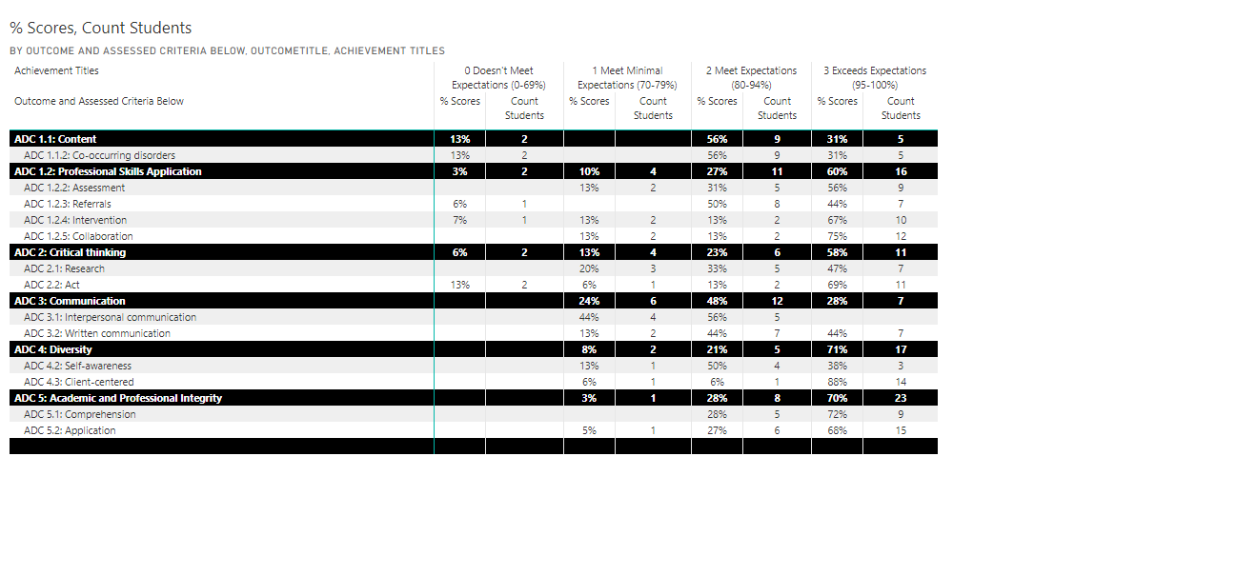
Future Plans
If you did not assess one or more of your outcomes this year, list them here along with the year they will be assessed. In addition, briefly describe long-term plans to improve the assessment process and/or student learning.

The preliminary assessment data revealed a need to make revisions to ADC 325 in an effort to better meet freshmen/sophomore students where they are at in the learning process. The course was originally set-up to challenge students to resolve various ethical dilemmas within class. However, it became clear that these simulations were not effective as a result of a majority of students 1. Not completing the required preparatory asynchronous lectures and reading assignments and 2. Reporting that they hadn’t yet reached a point in their college education where they felt comfortable “making mistakes” in front of their peers. As a result of the assessment findings and student feedback, ADC 325 has been restructured so that a majority of classroom time will be spent on covering key learning objectives. Whereas critical thinking assignments that challenge the students’ understanding of learning objectives will be included on asynchronous class days. We feel this shift will better equip students to make informed ethical decisions based on course content. It will also make it possible for students to explore their personal beliefs about tough ethical and values dilemmas in more detail with the knowledge that they will be able to choose whether they share their comments with the rest of the class. The ADC 325 format changes will also result in it no longer being used to assess interpersonal communication skills. This SLO will, instead, be monitored in upper-level ADC courses including ADC 570/SOCWK 570 Group Facilitation and ADC 630 Co-Occurring Disorders and Addiction Treatment.

The data did not demonstrate a need to revise ADC 561/SOCWK 561 at this time. Students scored well on assignments and reported that they felt their professional skills had enhanced “significantly” compared to when the semester had started as a direct result of the personal skill building goals they identified and monitored, the practice simulations, and the opportunity to work with a real client throughout the semester.

Summary of this Report
A one-paragraph summary to be posted on your program website and details student achievement of your program's learning outcomes, as well as programmatic efforts to improve. If this report occurs during the Board of Regents Program Review, this paragraph will be the 8-year summary included in Section 3 of your Program Review Report (PRR).

The Addiction Counseling Program’s 2023-2024 assessment data revealed we accomplished our goal of a minimum of 90% of addiction counseling students meeting or exceeding expectations for two of our five Student Learning Objectives. While this preliminary data was based solely on two initial course offerings of the new degree program, it demonstrated which assessment measures these two courses are meeting and what changes we can make to better prepare future students. When each individual measure is evaluated, only one of the 13 measures produced results were less than 80% of students demonstrated mastery skills. Our primary objectives when looking towards 2024-2025 will be to launch and evaluate the remaining courses that make up the new Addiction Counseling degree and recruit additional instructors to teach these courses.

