Project LEAPES Professional Development: Computer Science
Friday, April 8, 2022, 10 AM – 3 PM
K-State Salina Campus, College Center Conference Room

9:30 AM – 10:00 AM | Check-In/Registration  REC Team
10:00 AM – 10:10 AM | Welcome/Introductions  REC Team  Overview of grant programs  Dr. Spencer Clark
10:10 AM – 10:20 AM | Overview of How the Summer STEAM Academy Operates  Classroom/Day of Activities  Zoom Instruction vs Facilitating Teacher Instruction  Promotion to Parents/IRB discussion  Diane/Spencer
10:20 AM – 11:10 PM | Live Coding Exercise & Discussion  Nathan Bean
11:10 AM – 12:00 PM | Use-Modify-Create Exercise & Discussion  Nathan Bean
12:00 PM -12:30 PM | Lunch @ Salina Campus Cafeteria (free - paid for by REC)
12:30 PM – 2:50 PM | PM Computer Science Training  Why Teach CS?  Kansas State Standards  Diversity and Inclusion Issues in CS  Nathan Bean
2:50 PM – 3:00 PM | End of Day Announcements

The session will be recorded via Zoom and distributed ASAP. Please contact Kevin Colle with questions about the session. klcolle@ksu.edu or (785) 532-1199.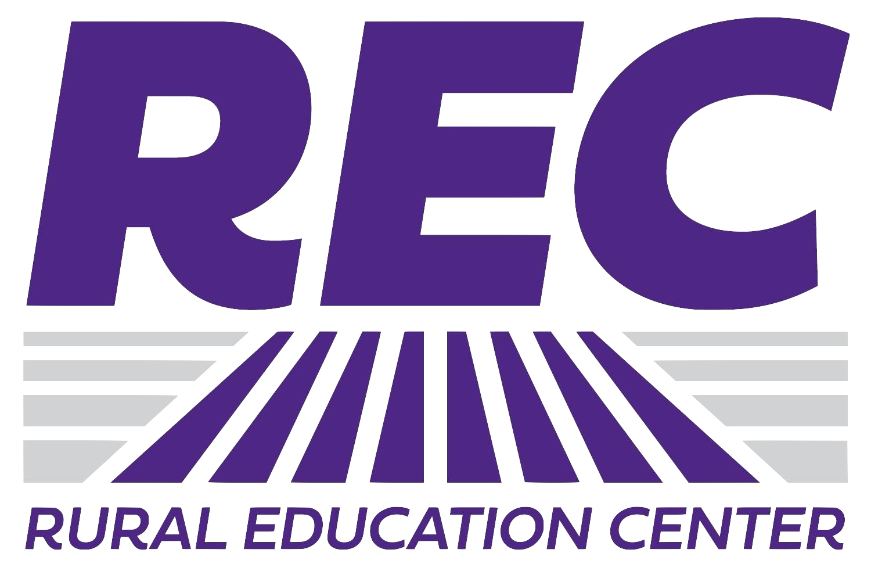

Directions to Salina Campus
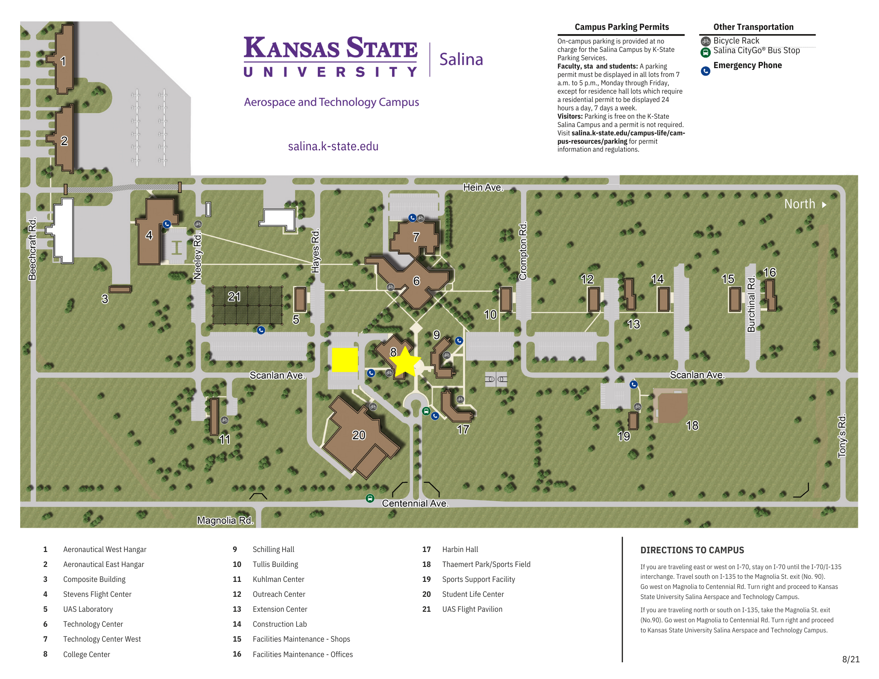The College Center Conference Room is in Building 8 (marked by star). Please park in the lot South of the building (marked by yellow square). Parking is free on the K-State Salina campus, no permit is required.

Directions from I-70 and I-135:
If you are traveling east or west on I-70, stay on I-70 until the I-70/I-135 interchange. Travel south on I-135 to the Magnolia Road exit (No. 90). Go west on Magnolia Road, then north on Centennial Road and proceed to the K-State Salina campus.
If you are traveling north or south on I-135, take the Magnolia Road exit (No. 90). Go west on Magnolia Road, then north on Centennial Road and proceed to the K-State Salina campus.

